Tackling unstructured problems
‘Do I stand back and watch, or intervene and tell them what to do?’

Introduction
In most mathematics and science classrooms, students are provided with structured tasks and are told precisely which techniques to deploy. Students learn by following instructions. Problems and situations that arise in the world are not usually like this. Rather than being exercises in the use of a particular skill or concept, real-world problems require students to make simplifications, model situations, choose appropriate knowledge and processes from their 'toolkit', and test whether their solution is "good enough" for the purpose in hand.

It seems logical that if students are to learn to use their skills autonomously in their future lives, they will need some opportunities to work on less structured problems in their classrooms. This unit compares structured and unstructured versions of problems and considers the demands and challenges unstructured problems present to students and teachers.

Activities
Activity A: Revising structured problems 2
Activity B: Compare structured and unstructured problems 4
Activity C: Consider strategies for offering help 6
Activity D: Observe and analyse a lesson 8
Activity E: Plan a lesson, teach it and reflect on the outcomes 9
Further reading 10
References 10

Acknowledgement:
This material is adapted for PRIMAS from:
Swan, M; Pead, D (2008). Professional development resources. Bowland Maths Key Stage 3, Bowland Trust/ Department for Children, Schools and Families. Available online in the UK at: http://www.bowlandmaths.org.uk. It is used here by permission of the Bowland Trust.

Activity A: Revising structured problems

Time needed: 20 minutes.
Handout 1 presents three structured problems:

- Organising a table tennis tournament
- Designing a box for 18 sweets
- Calculating Body Mass Index

These problems are of the same type as those typically found in many Mathematics and Science Classrooms. The first two are practical group tasks and the third is a computer-based task. These are, however, structured so that they lead students through the problems, guiding and making decisions for them.

- Work through one of the structured problems carefully.
- List all the decisions that are being made for the students.
- Revise the problems so that some of these decisions are handed back to students.
This will make them less structured.

For example, in Organising a table tennis tournament, pupils are told:
- how to code the players (A, B, C .. etc)
- to list all the matches that need to be played
- how to systematically organise these matches
- how to tabulate the order of play
- to remember that players cannot play on two tables at once.

Handout 1: Structured problems
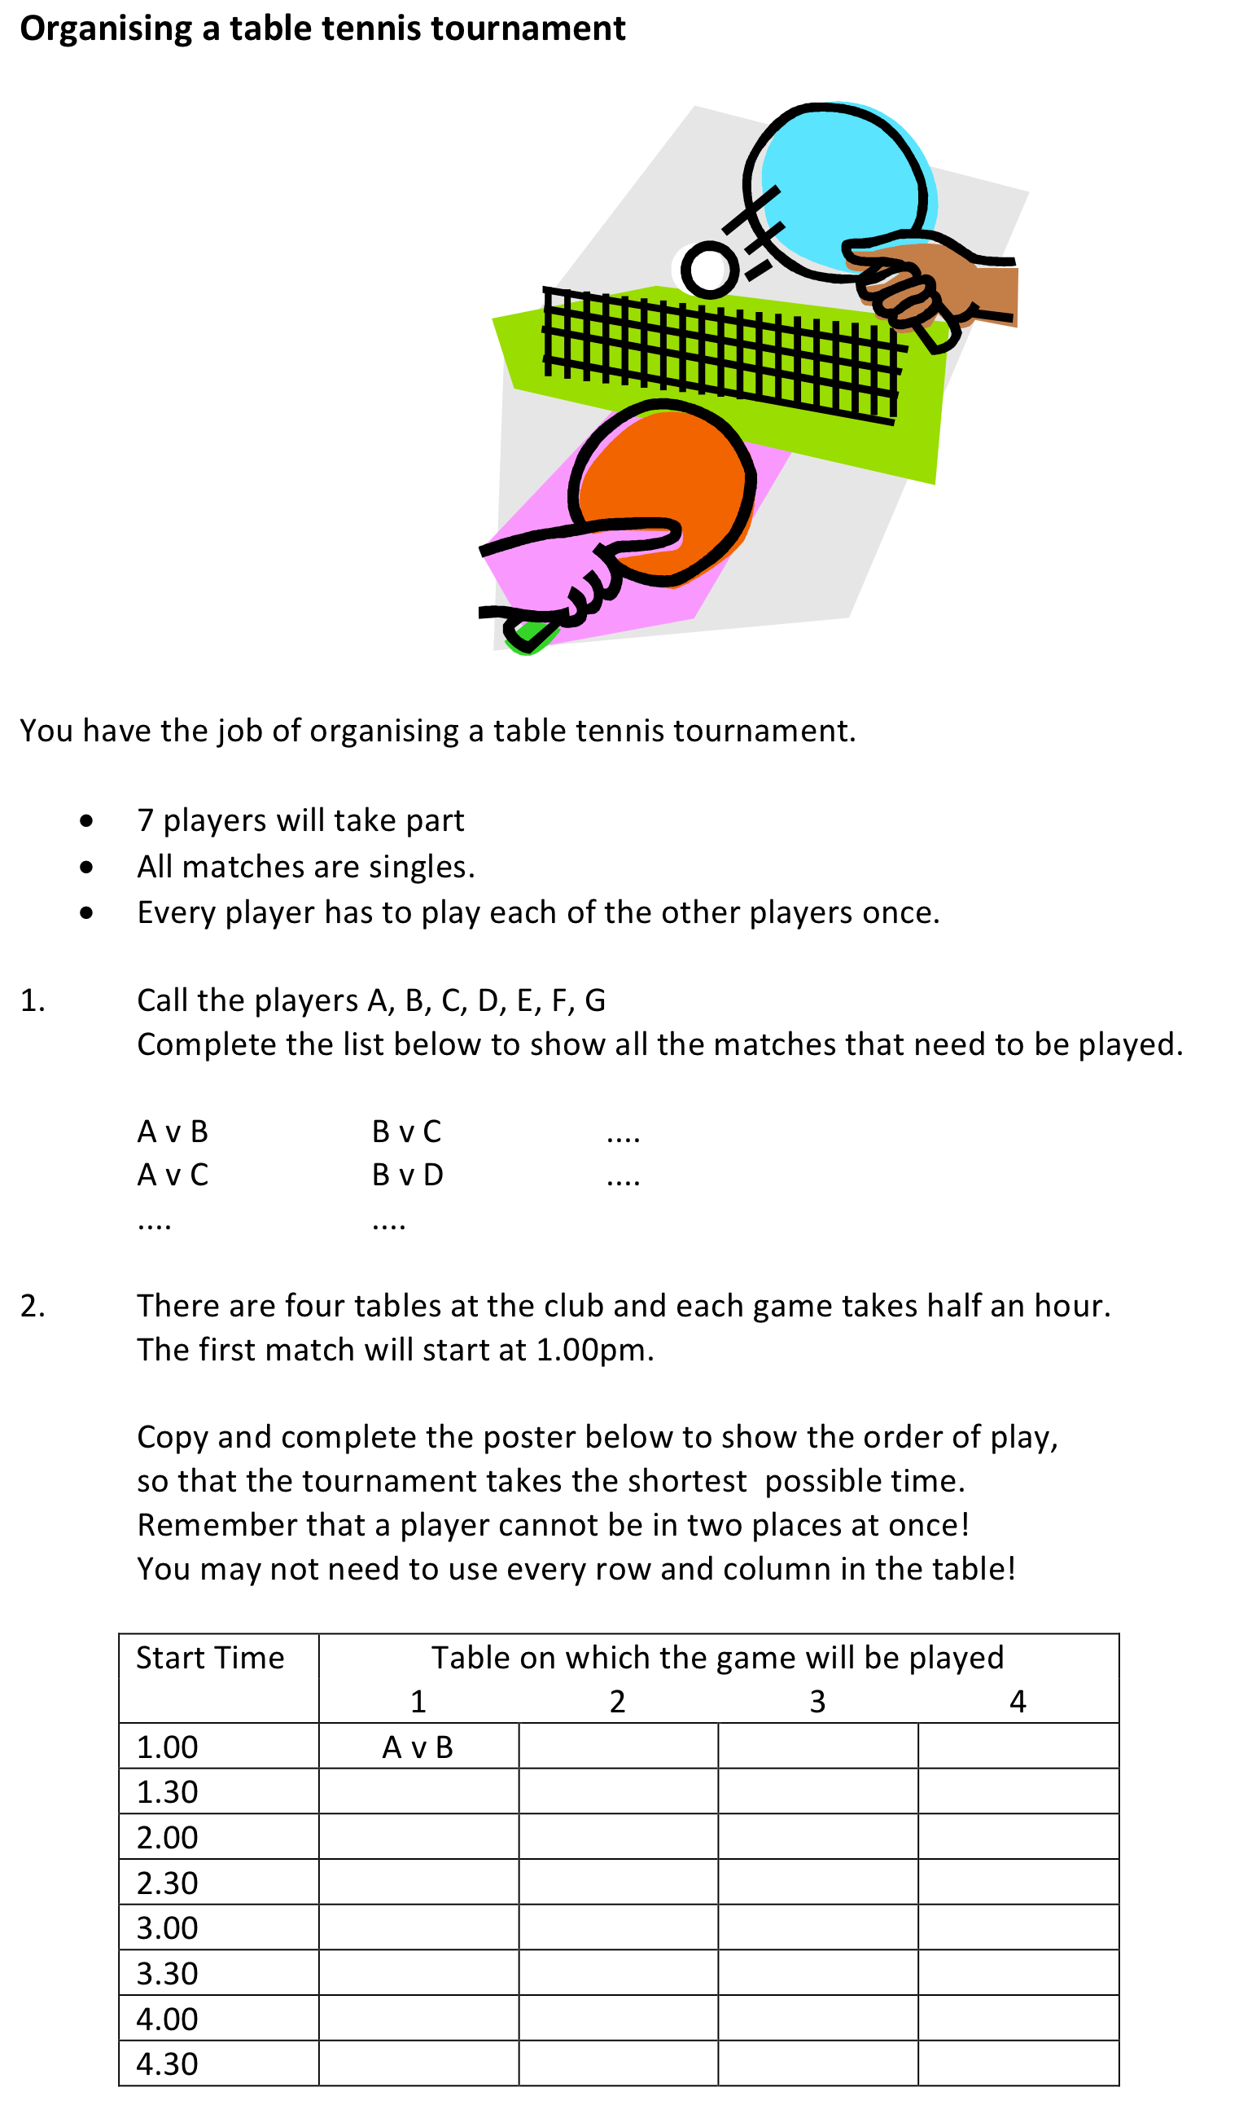
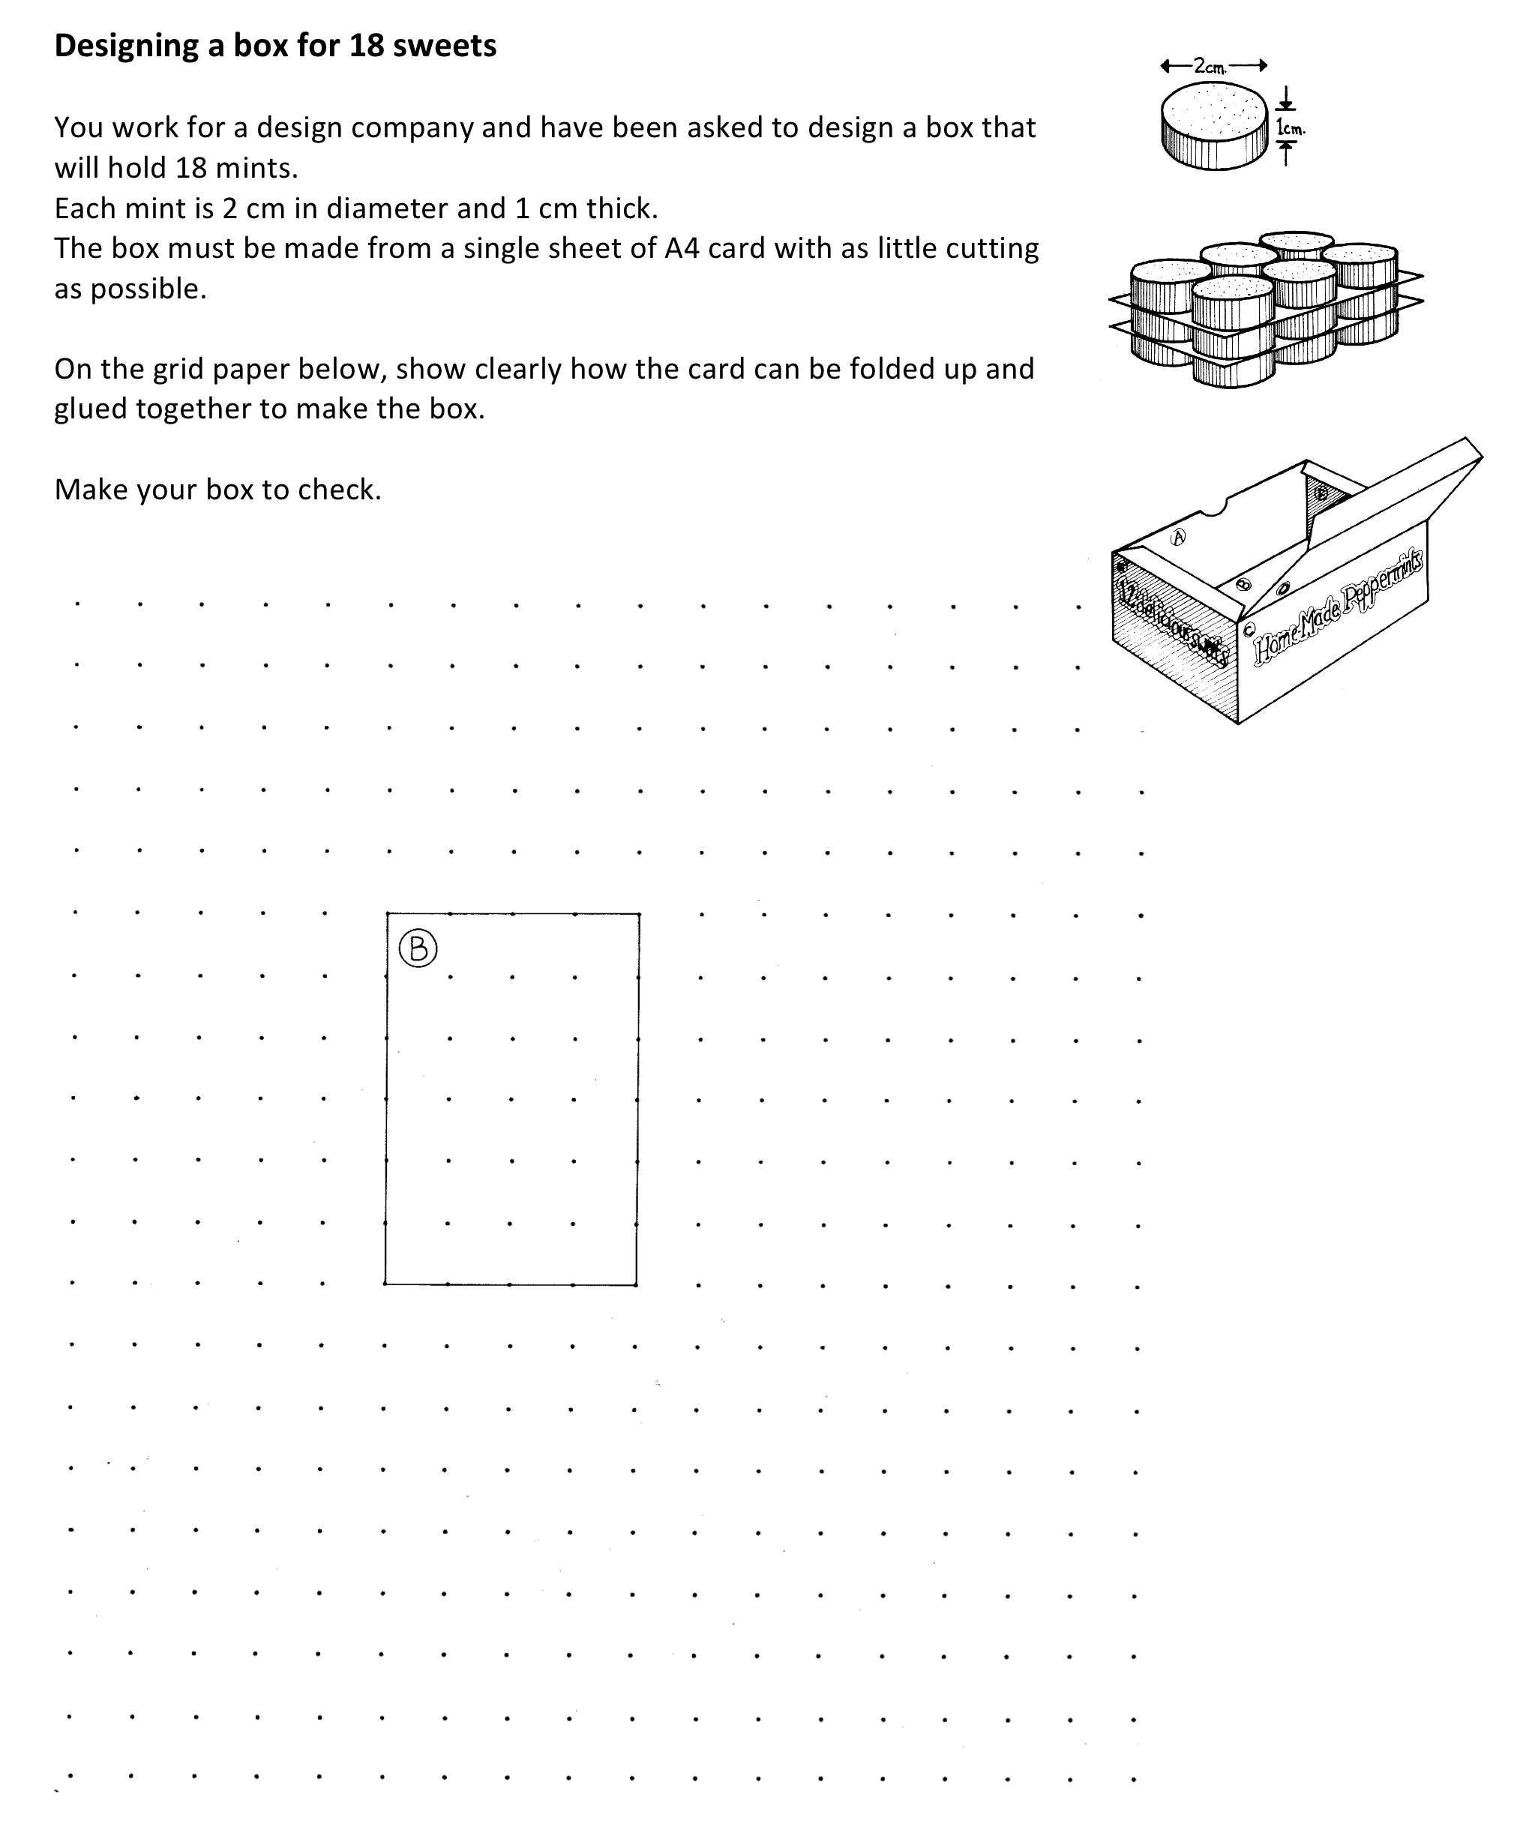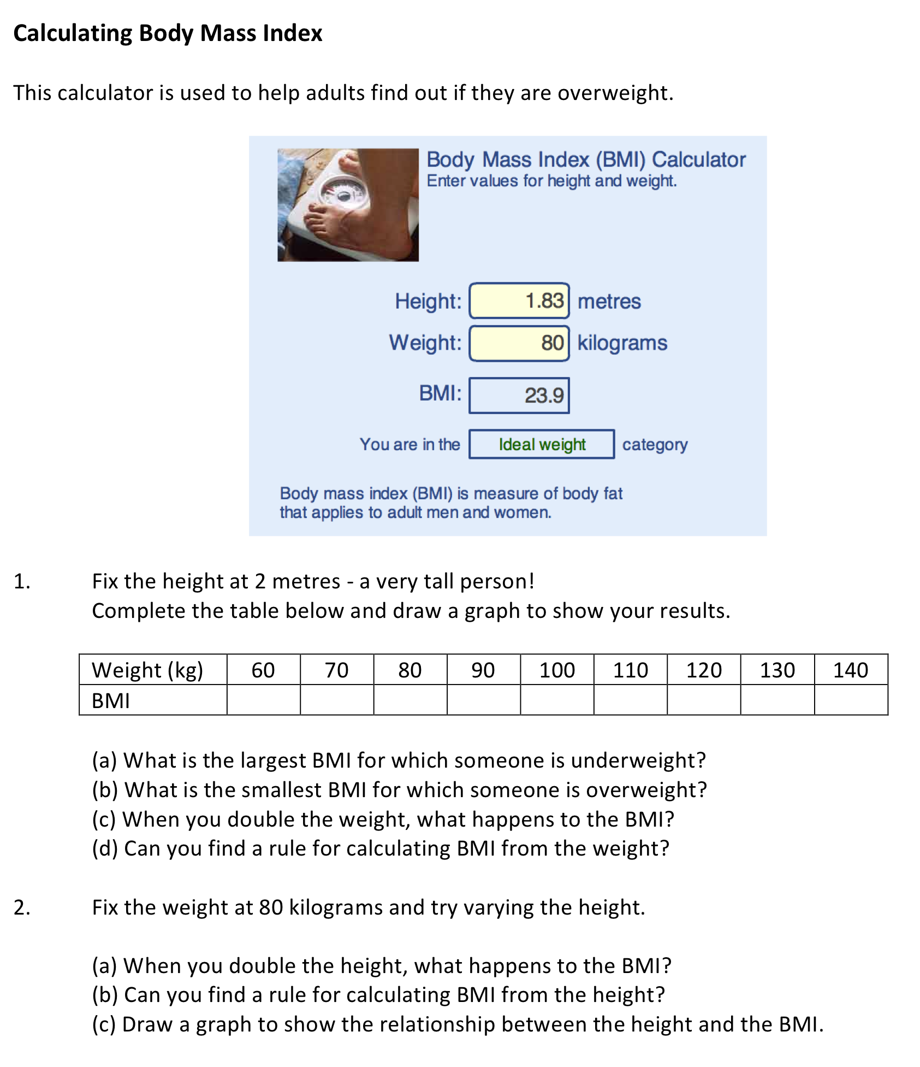

Activity B: Compare structured and unstructured problems

Time needed: 10 minutes

Handout 2 contains unstructured versions of the same tasks that were used in activity A.
- Compare the less structured versions of the problems with the structured versions.
- What decisions have been left to the students?
- What pedagogical issues will arise when you start to use unstructured problems like this?

Some immediate issues that teachers raise are:
- Unstructured problems are more difficult.
- It is more difficult to plan a lesson with these problems.
- Students may not even know how to get started on them. Will we therefore need to structure them anyway?
- Students will not necessarily use what we have taught them.
- If we offer help too quickly, students will simply do what we say and not think for themselves.
- Students will generate a greater variety of approaches and solutions.
- Students may need reassurance that it is OK to try a different approach or reach a different conclusion.

Handout 3 contains some notes on the solutions to the three problems.

Handout 2: Unstructured versions of the problems

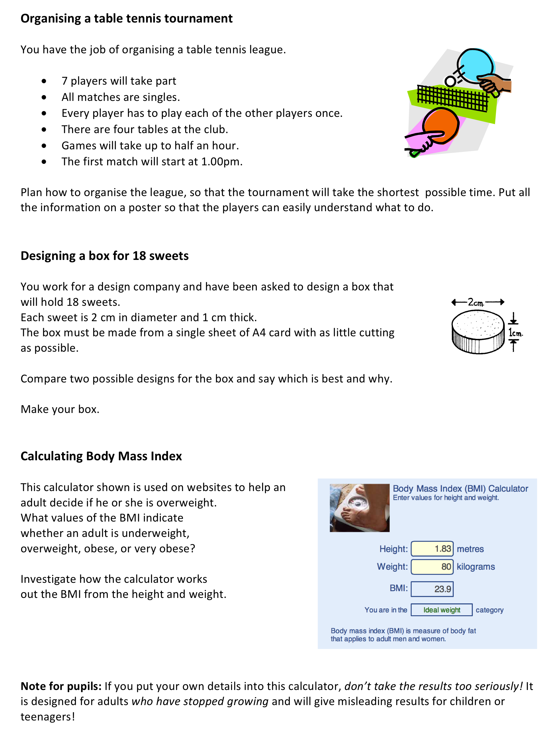

Activity C: Consider strategies for offering help

Time needed: 30 minutes.

Teachers often find it difficult to know when to give help and when to leave students struggling. If they intervene too quickly, then the students have no chance to experience what it is like to pursue an unfruitful idea, or to puzzle out a solution for themselves. If they intervene too slowly, then students become frustrated, bored and disengaged.

Handout 4 contains some practical advice when using unstructured problems. Consider this advice carefully:
- Which ideas do you normally find most difficult to implement? Why is this?
- Is there any other advice you would add to this list? Write your own ideas at the bottom.

Bruner uses the metaphor of scaffolding to describe the structuring that a teacher provides (D. Wood, Bruner, & Ross, 1976). The teacher encourages students to as much as they are capable of unaided and only provides the minimum of support to help them succeed. This support may involve reducing their choices, drawing attention to important features through questioning, or even at times demonstrating what to do. In his work with young children, Wood (1988) categorised different levels of scaffolding, from less directive to more directive: giving general verbal advice, giving specific verbal instructions, breaking the problem down, demonstrating a solution. Wood also introduced two rules of contingency:
"Any failure by a child to succeed in an action after a given level of help should be met by an immediate increase in help or control. Success by a child then indicates that any subsequent instruction should offer less help than that which preceded the success, to allow the child to develop independence." Wood (1988)
The important idea here is that scaffolding should be removed as the student begins to cope, otherwise it reinforces dependency.

Handout 4: Practical advice for teaching problem solving

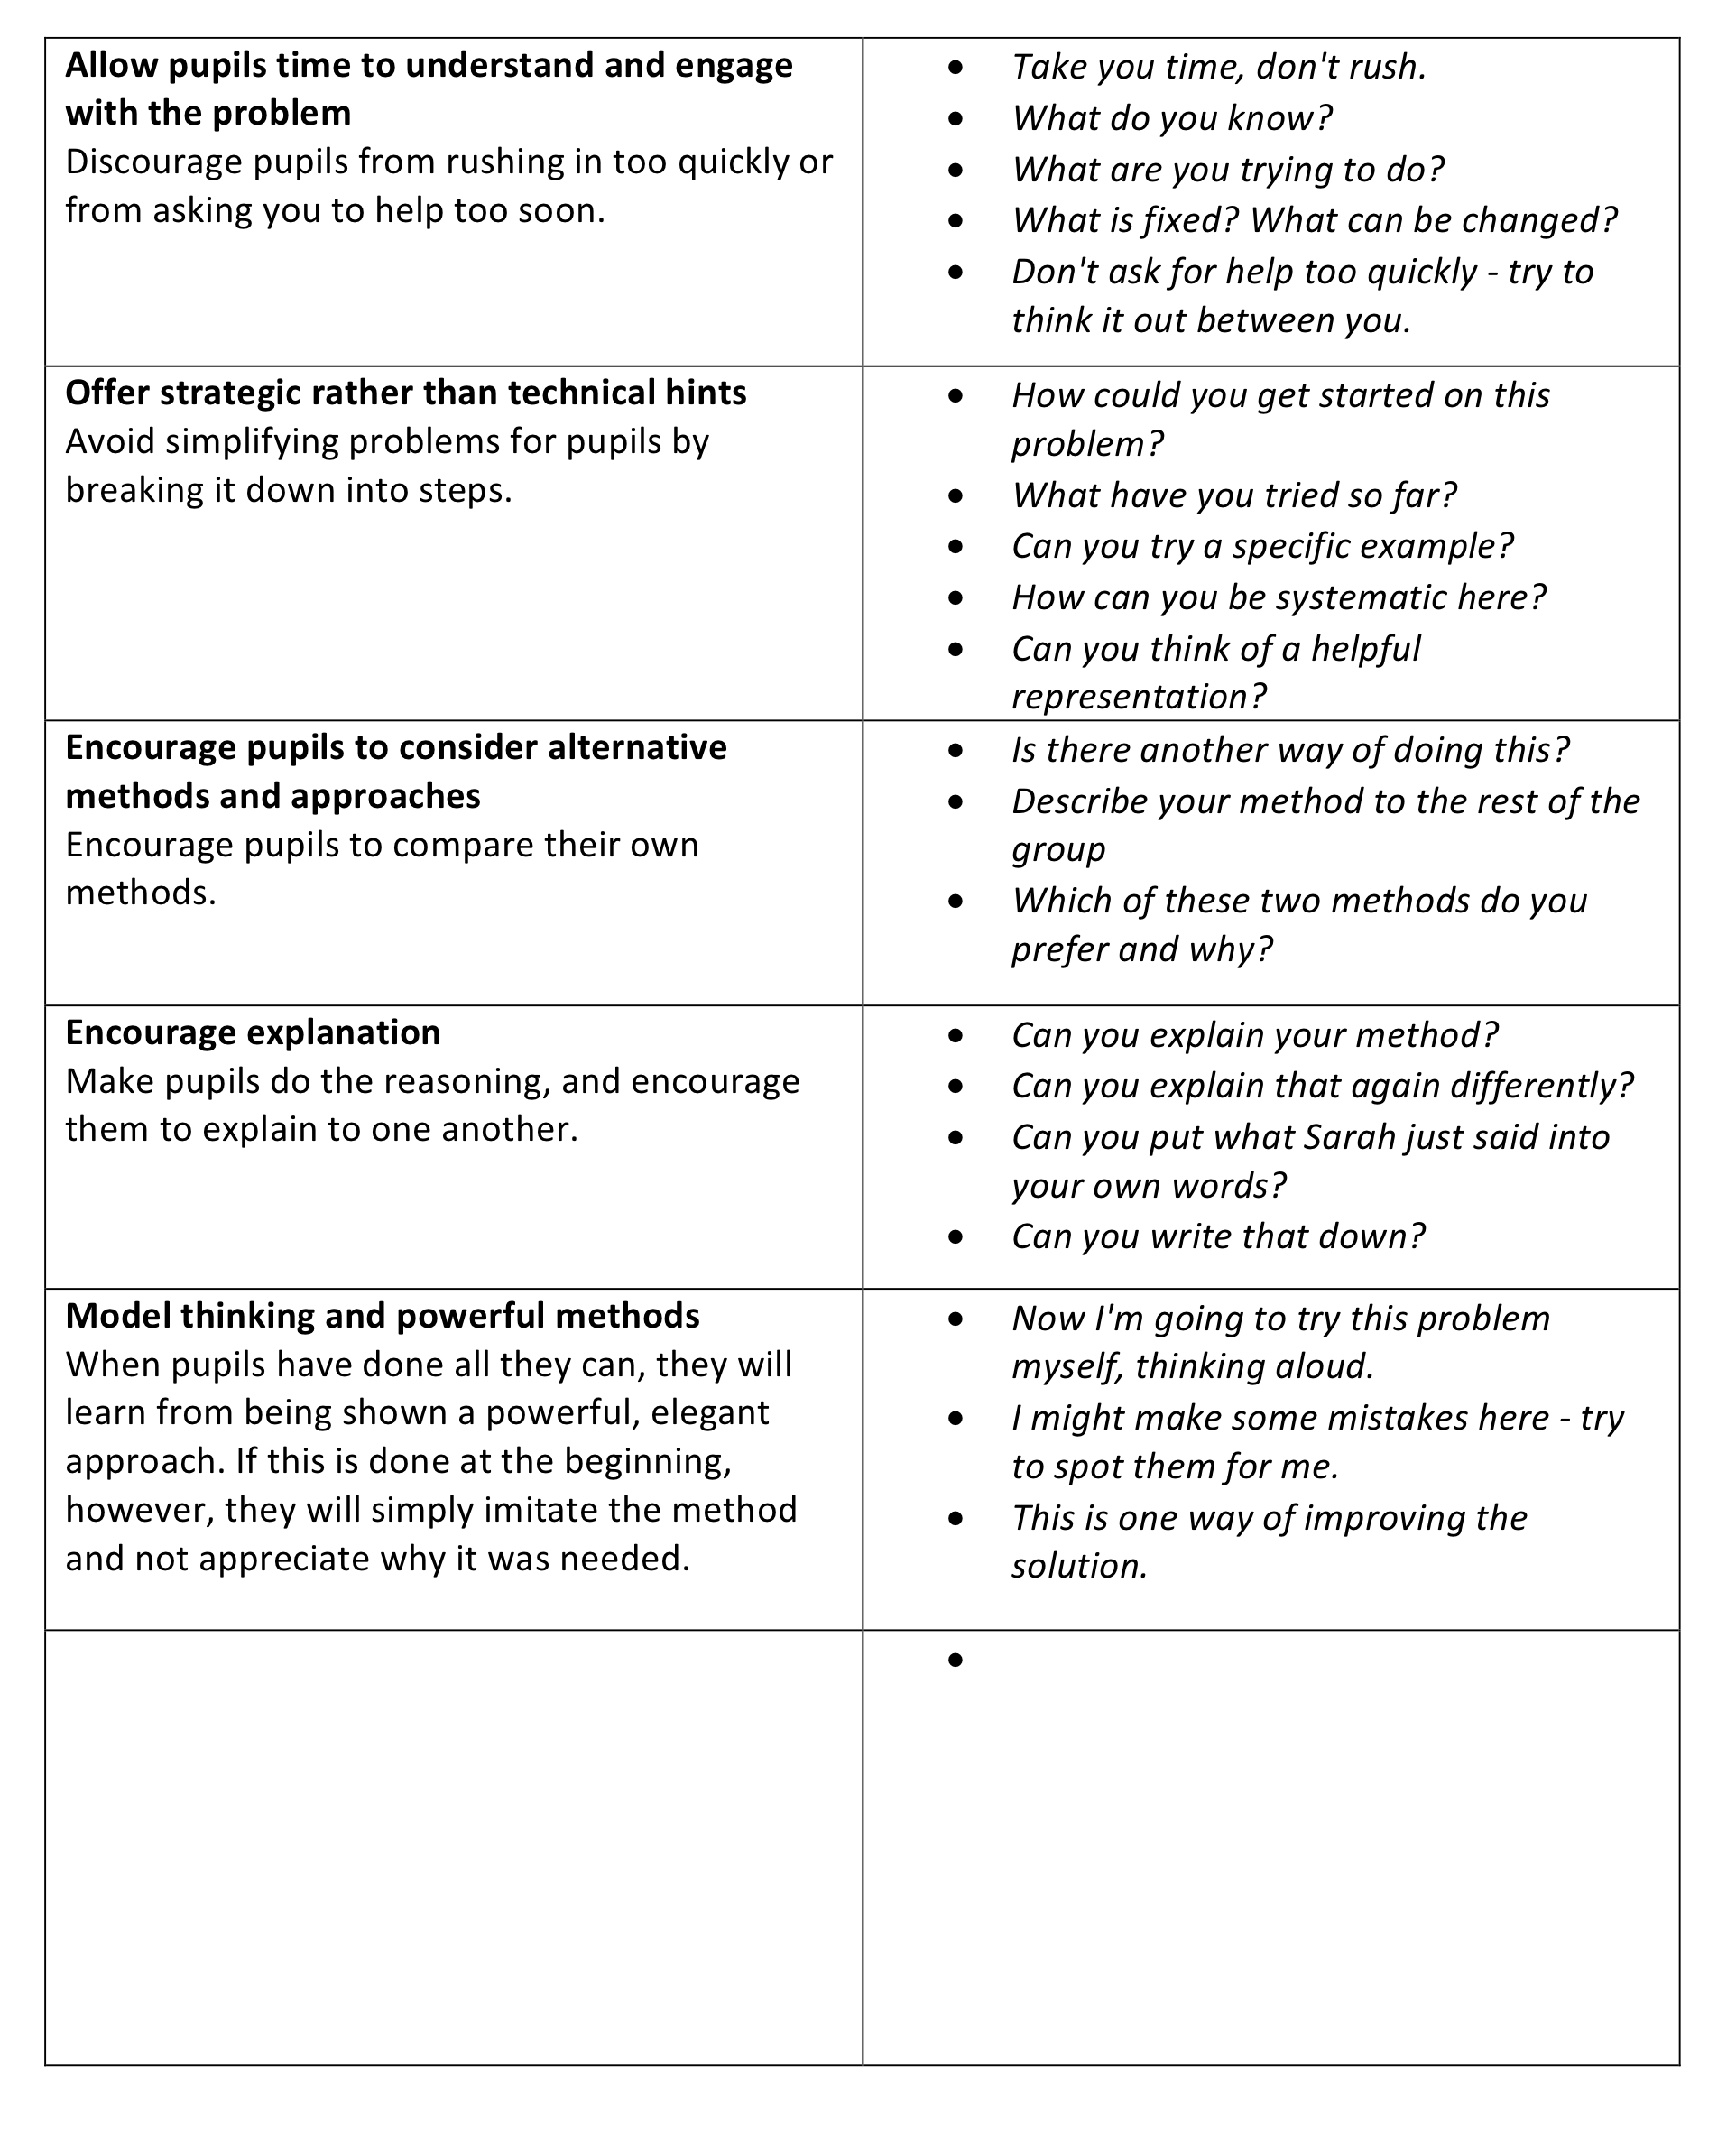

Activity D: Observe and analyse a lesson

Time needed: 30 minutes.
The two video clips show students working with the unstructured versions of the same problems you have worked on. Watch Michelle using the Organising a table tennis tournament problem.
As you watch the video, consider:

- How did the teacher organise the lesson? What phases did it go through?
- What resources did the teacher have available, and when were these used?
- Why were students expected to work in pairs/ small groups?
- How did the teacher introduce the problem to students?
- What different approaches were being used by students?
- How did the teacher support the students that were struggling?
- How did the teacher encourage the sharing of approaches and strategies?
- What do you think these students were learning?

Afterwards you may enjoy watching the second video clip of Judith's lesson where she asks the class to design a box to hold 18 sweets.

Michelle begins the lesson by introducing the problem and also by explaining how the students should work together. The students are then given 3-4 minutes to write their individual, initial ideas of how they will tackle the problem. This helps them to formulate their ideas and have some ideas to contribute to the group discussions. Students were then given a few minutes to discuss their ideas. The video shows students getting to grips with the problem and the constraints involved. Some for example realise that 4 tables will not be needed.

At this point, Michelle introduces the resources that are available for them to use. She emphasises that they should not rush the problem solving and that some may not get finished. She says that the important thing is to think about the approaches.

While groups work, Michelle first listens, then intervenes to promote deeper thinking:
" You've found one approach. You've found that it is not going to quite work, is it?
So what do we need to do from there?"
"Re-read the problem. Look at the last two sentences."
Students use a wide range of representations and resources to solve the problem. Some used tables, while others used counters. These methods are shared in the final whole discussion.

Activity E: Plan a lesson, teach it and reflect on the outcomes

Time needed:
- 15 minutes discussion before the lesson
- 1 hour for the lesson
- 15 minutes after the lesson

Choose one of the three problems that you feel would be appropriate for your class.

Discuss how you will:

- Organise the classroom and the resources needed.
- Introduce the problem to pupils.
- Explain to pupils how you want them to work together.
- Challenge/assist pupils that find the problem straightforward/ difficult.
- Help them share and learn from alternative problem-solving strategies.
- Conclude the lesson.

If you are working on this module with a group, it will be helpful if each participant chooses the same problem, as this will facilitate the follow-up discussion.

Now you have taught the lesson, it is time to reflect on what happened.

- What range of responses did pupils have to this way of working?
Did some appear confident? Did some need help? What sort of help? Why did they need it?
- What support and guidance did you feel obliged to give?
Why was this? Did you give too much or too little help?
- What different strategies did pupils use?
Share two or three different examples of pupils' work.
- What do you think pupils learned from this lesson?
If there is time, you may also like to watch the videos of the teachers as they reflect on their own lessons with the Table tennis and Sweet box problems.

Further reading
The seminal text for asking pupils to think mathematically
Mason, J., Burton, L. and Stacey, K. (1982) Thinking Mathematically, London: Addison-Wesley

The book that inspired so much of the research into problem solving heuristics (or what to do when you are 'stuck')
Polya, G. (1957) How to Solve It: A New Aspect of Mathematical Method, (2nd Ed) Penguin Science.

References
Wood, D. (1988). How Children Think and Learn. Oxford and Cambridge, MA: Blackwell.
Wood, D., Bruner, J., & Ross, G. (1976). The role of tutoring in problem solving. Journal of child psychology and psychiatry, 17, 89-100.

