Student-led inquiry
How might students be encouraged to ask and follow-up their own questions?

Introduction

At its most fundamental, inquiry-based learning is about engaging students' curiosity in the world and the ideas that surround them. As scientists and mathematicians, they observe and pose questions about situations; if their questions are too complex, they may try to simplify or model the situation; they may then try to answer their questions by collecting and analyzing data, making representations, and by making connections with what they already know. They try to interpret their findings, check that they are accurate and sensible and then share their findings with others.

This process is often missing in the school classroom. There, the teacher usually points out what must be observed, she provides the questions, demonstrates the methods to be used and checks the results. Students are merely asked to follow the instructions.

In this module, teachers will be encouraged to experience what it feels like to think like a mathematician or scientist, and reflect on the role shifts that are necessary for students to share this experience in the classroom. Teachers are shown phenomena and situations and are invited to pose and pursue their own questions. This experience is then transferred to the classroom.

Activities
Activity A: Ask questions about phenomena 1
Activity B: Making observations from photographs 4
Activity C: Observe and analyse a lesson 6
Activity D: Plan a lesson, teach it and reflect on the outcomes 8
Suggested further reading 10

Acknowledgement:
This material is adapted for PRIMAS from:
Swan, M; Pead, D (2008). Professional development resources. Bowland Maths Key Stage 3, Bowland Trust/ Department for Children, Schools and Families. Available online in the UK at: http://www.bowlandmaths.org.uk
It is used here by permission of the Bowland Trust.

Activity A: Ask questions about phenomena

Time needed: 30 minutes.
In this activity, you may like to offer teachers a choice of two possible starting points:
- One involves rolling a paper cup
- The other involves a piece of computer software: Spirolaterals

For the first activity, you will need to provide each group of teachers with at least three different paper cups. Try to include a 'short and fat' one and a 'long and thin one' and 'one in between'
For the second, we have provided a computer microworld. Teachers will need to work in pairs using a laptop.

For the situation you choose to explore:
- Make a list of things you notice about the situation.
- What questions occur to you?
- You might begin by asking questions that start:
  - What would happen if ....?
  - What can I vary ...?
  - What effect will each variable have on ...?
- Now set yourself a problem and attempt to tackle it.

When you have experimented with the situation try to analyze your findings.
- What data have you collected?
- How have you organized your data?
- How can you explain your findings?

After teachers have explored both situations ask them to reflect on the process they have been through. Handout 2 will help them do this. Did they:

Formulate problems?
- list variables?
- simplifying and represent?
Analyse and solve?
- visualise; draw diagrams?
- systematically change variables?
- look for patterns and relationships?
- make calculations and keep records?
- make conjectures and generalisations?
- use logical, deductive reasoning?
Interpret and evaluate?
- form conclusions, arguments and generalisations
- consider appropriateness and accuracy
- relate back to the original situation
Communicate and reflect?
- communicate and discuss findings effectively
- consider alternative solutions
- consider elegance, efficiency and equivalence
- Make connections to other problems?

Handout 1: Phenomena to explore

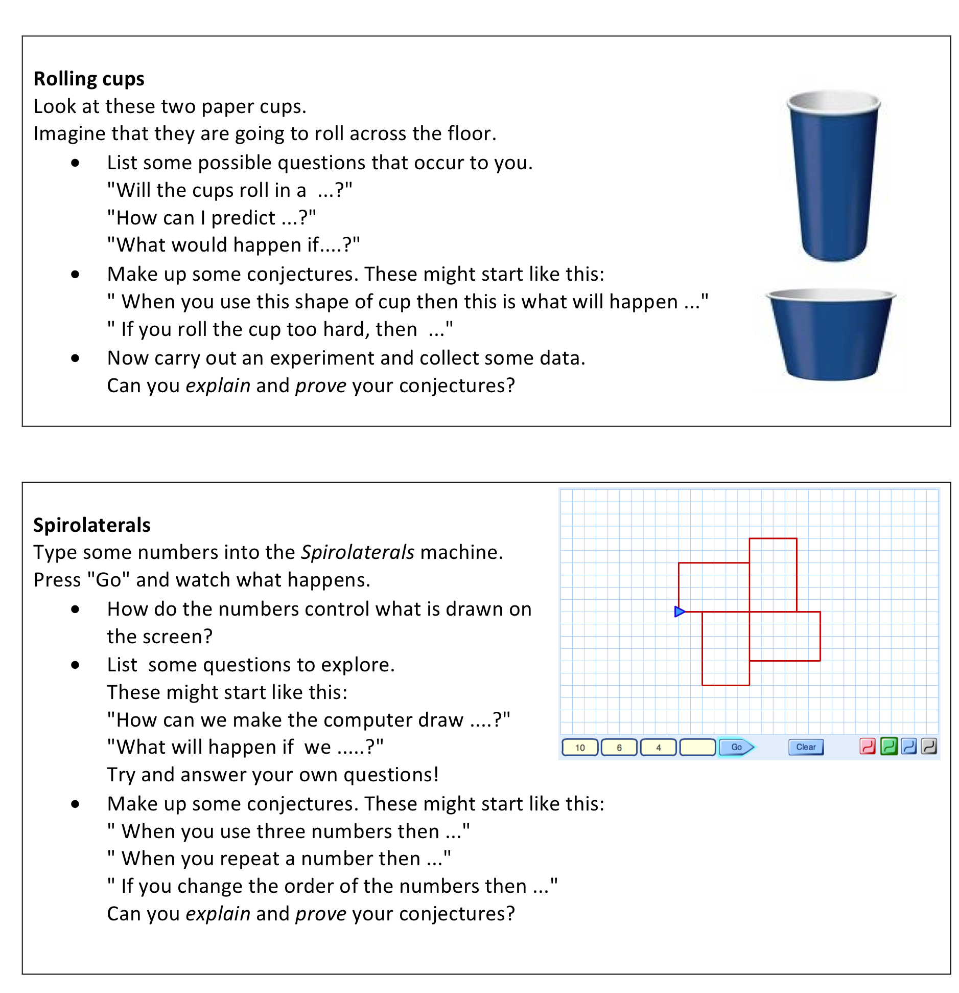

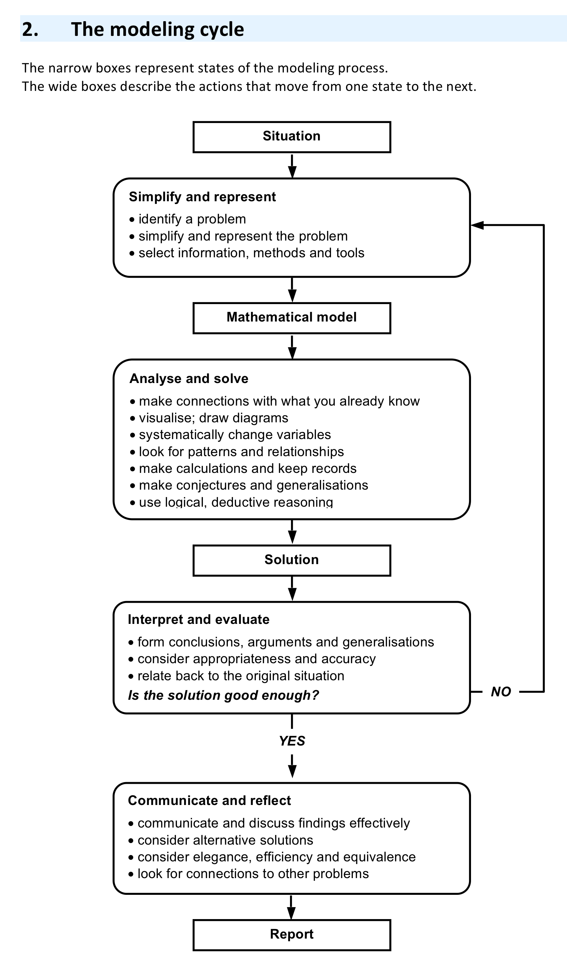
Handout 2: The modeling cycle

Activity B: Making observations from photographs

Time needed: 20 minutes.
It is not always easy for pupils to see any connection between the real world and their lessons in school. As a result, they don’t use what they learned in secondary school, even though thinking scientifically could help them understand the world better – and make better decisions.

Look at the selection of photographs on Handout 1.
- Make a list of things you notice about the situation.
- What questions occur to you?
- You might begin by asking questions that start:
  - How many ...?
  - What would happen if ....?
- Now set yourself a problem attempt to tackle it.

After teachers have explored both situations ask them to share some of the questions they have created. For example, the following selection came from one group:

Dominoes:
- Which domino is missing?
- How can you organize the dominoes systematically?
- Can you make a chain or a ring with the complete set?
- How many spots are there in a complete set? What is a quick way of counting them?
- How many dominoes are there in a complete set from (1,1) to (n,n)?
Calendar:
- How are the numbers arranged on the cubes?
- Can you draw nets and make the cubes?
- What impossible dates can be made from these cubes?
Stack of barrels
- How many barrels are in the stack?
- If you make a taller stack 4, 5, ... barrels high, how many barrels will you need? Generalize?
- How else could you stack these barrels? What other pyramids are possible?
A pavement in Germany
- Are all the paving slabs identical? What shape are they? Can you work out any angles?
- Can you draw one of the slabs accurately?
- Can you find other pentagons that tessellate?
- What other shapes can paving slabs be?
Trike with square wheels
- Does the trike run smoothly? Can you make a simple model?
- What is the height of each 'bump' on the track?
- Can you draw the shape of the 'bumpy road' accurately?
- What would happen if you had triangular wheels or hexagonal wheels?
Russian dolls
- Do the tops of the heads lie on a straight line? What does this tell you?
- If you were to make some bigger dolls in this set - how big would they have to be?

Ask teachers to bring their own photographs to a follow-up session and develop questions about them. Generating questions is an activity that is essential for inquiry-based learning. We will see in a later session how students may be encouraged to develop their own questioning.

Handout 3. Photographs to explore
Dominoes  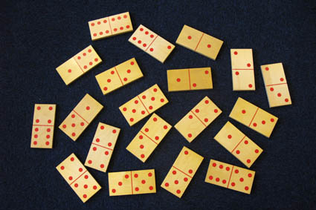 | Calendar  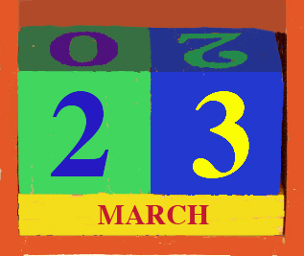
Barrels  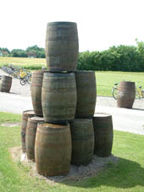 | Pavement in Germany  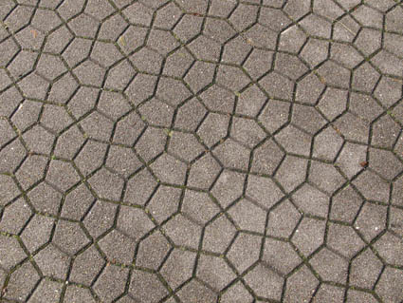
Trike with square wheels  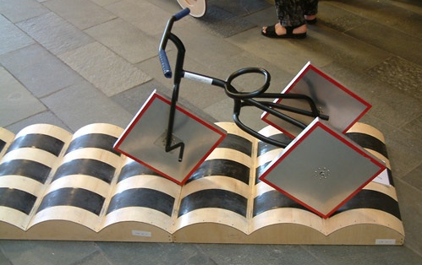 | Russian Dolls  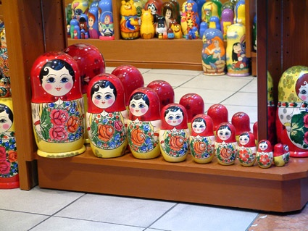

Activity C: Observe and analyse a lesson

Time needed: 30 minutes.
We have provided two videos of lessons for teachers to watch.
Choose just one of these.
One video uses the Spirolaterals problem from Activity A
One video uses the Building a School photographs shown opposite.
Each video lasts about 10 minutes.

As you watch each lesson, ask yourself:
- Which processes can you see in the work of these pupils?
- Can you see them:
  - Simplifying and representing the situation?
    - What questions did they formulate?
    - What simplifications and representations did they create?
    - What choices did they make of information, methods and tools?
  - Analysing and solving the model they’ve made?
    - Which variables did they consider?
    - What information did they collect, or guess?
    - What relationships did they formulate?
    - What calculations did they make?
  - Interpreting and evaluating the results?
    - What did they learn about the situation?
    - Were their results plausible?
  - Communicating and reflecting on the findings?
    - How did they explain their analyses?
    - What connections did they see to other problems?

Handout 4: Building a school with bottles in Honduras
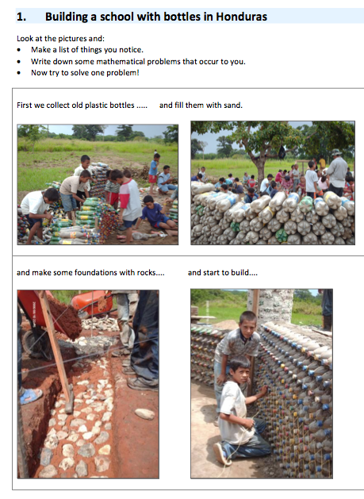 | 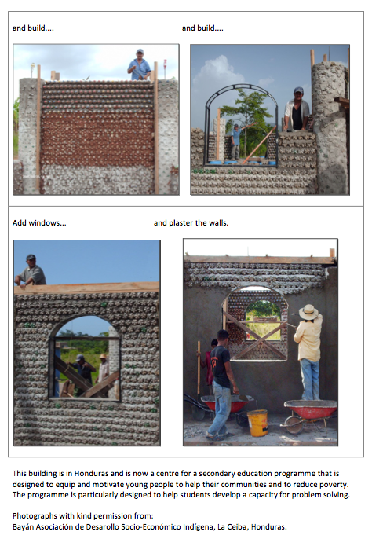

Handout 5. The modeling cycle applied to the “building a school” task.

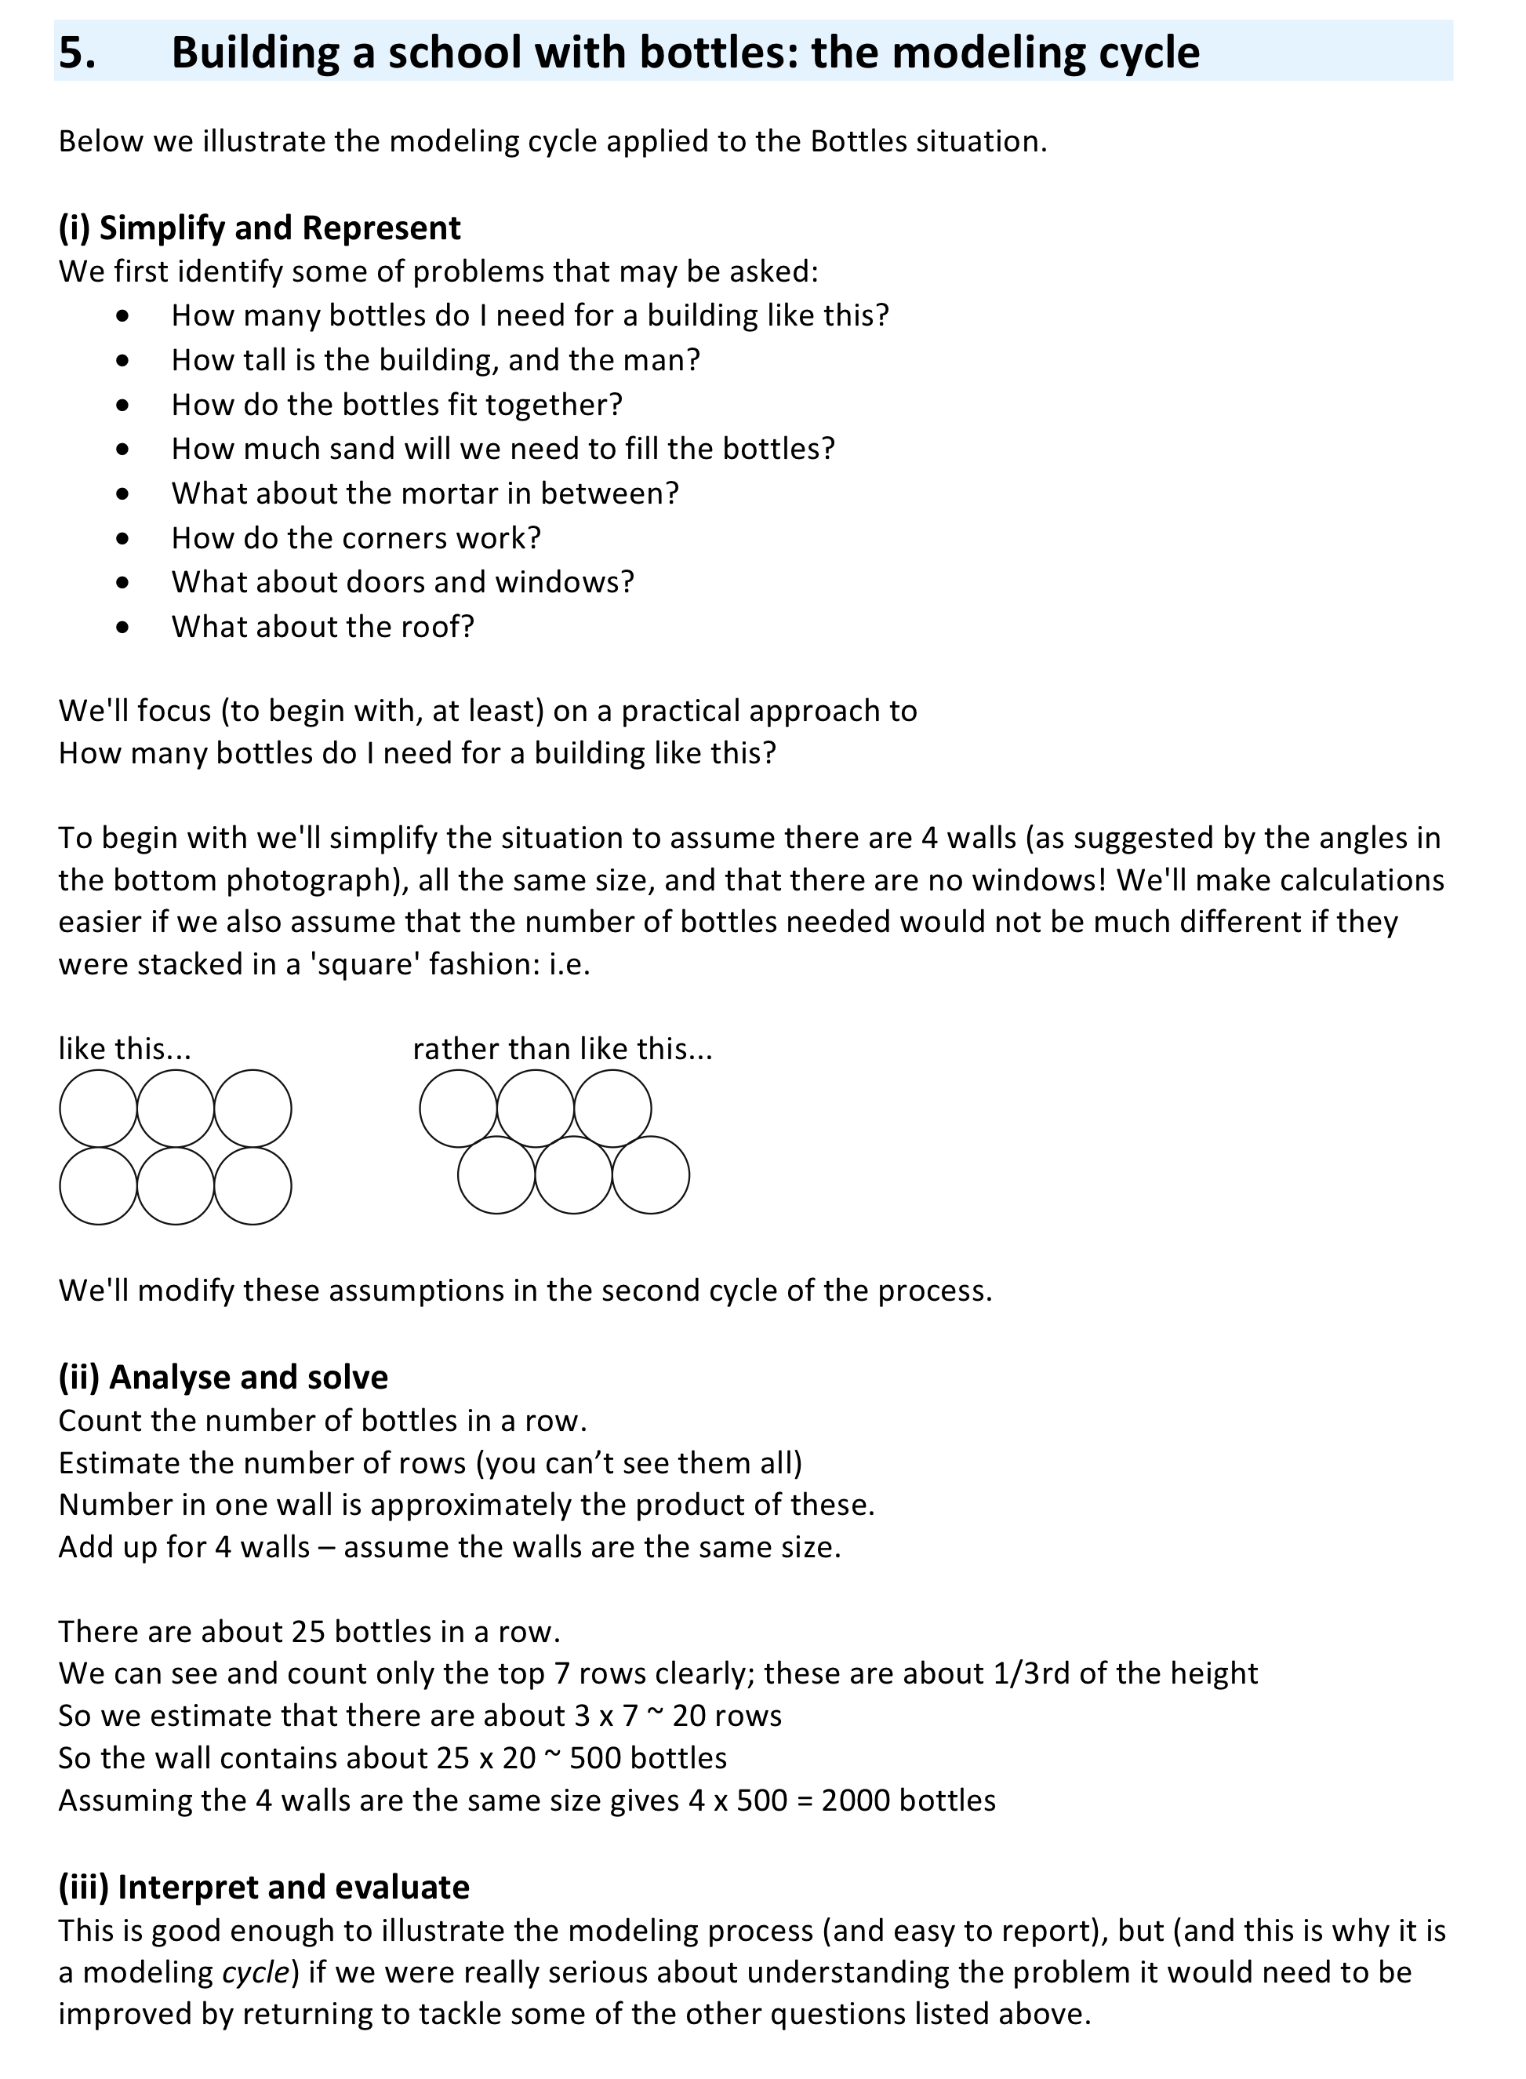

Activity D: Plan a lesson, teach it and reflect on the outcomes

Time needed:
- 15 minutes discussion before the lesson
- 1 hour for the lesson
- 15 minutes after the lesson

Now it is your turn to plan a lesson using the Building a School or the Spirolaterals situation from Activity C.
Discuss how you will:
- introduce the situation to pupils;
- introduce the idea of the modeling cycle;
- organise the classroom and the resources needed;
- answer the question "Why are we doing this in maths?";
- conclude the lesson in a way that gives pupils a better understanding of the nature of scientific processes involved.
After you have designed your lesson, compare your plan with the lesson plan supplied on Handout 6.
Discuss the differences.

It is helpful to present the lesson using a data projector. In addition, it is helpful to have a supply of the following resources available for working on the problems that arise:

- Some sample 1 litre plastic bottles
- Rulers or tape measures,
- Circular counters or coins (for working out how bottles pack together),
- Isometric dotted paper (to help with drawing and counting).
- Some copies of Handout 3 for pupils to use and discuss.

After you have taught the lesson, take some time to reflect on what happened and the processes that were in evidence.

- What questions were identified?
- Did pupils use a range of representations?
- What relationships did they find in the situation?
- What calculations did they do? Could they interpret the meaning of these?
- Were they able to communicate their conclusions effectively?
- Did your pupils feel that this was different from a normal lesson?
- Are they now beginning to appreciate how the techniques they have studied in school may be linked to unfamiliar situations?

Handout 6 A sample lesson plan

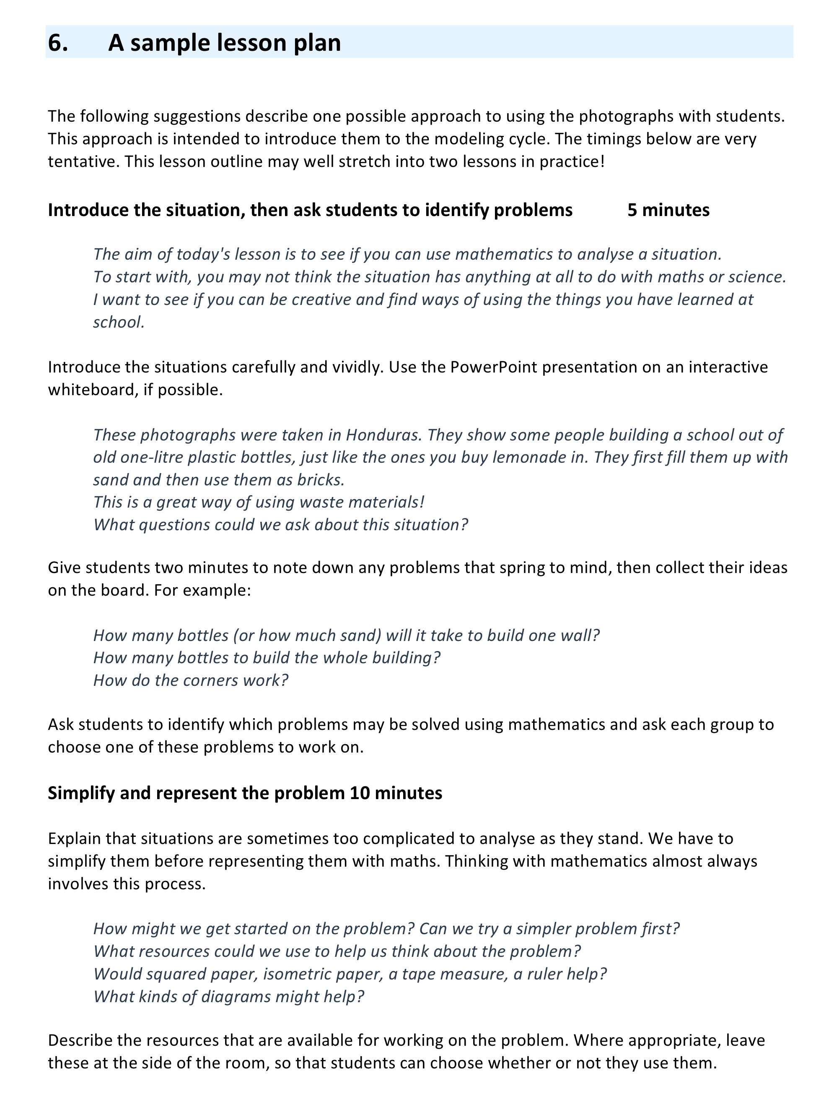

Suggested further reading
Learning mathematics through contextualised situations.
Boaler J. (1993) ‘The Role of Contexts in the Mathematics Classroom’, For the Learning of Mathematics 13(2)

Looking at the apprenticeship model of learning.
Brown, J. S., Collins, A. and Duguid, P. (1989) ‘Situated cognition and the Culture of Learning’, Educational Researcher, 18 (1), pp 32-42.

Looking at a different way to organise the Year 9 curriculum
Carter, C. (2008) ‘A different way’, Mathematics Teaching, 207, pp 38-40
http://www.atm.org.uk/mt/archive/mt207files/ATM-MT207-38-40-mo.pdf

What do pupils see as mathematical? Does it have to have numbers?
Mendick, H., Moreau, M. and Epstein D. (2007) ‘Looking for mathematics’ in D. Kuchemann (Ed.) Proceedings of the British Society for Research into Learning Mathematics 27 (1) pp 60 – 65
http://www.bsrlm.org.uk/IPs/ip27-1/BSRLM-IP-27-1-11.pdf

A comparison of the mathematics people use in school and out of school.
Nunes, T., Schliemann, A.D., Carraher, D.W. (1993), Street mathematics and school mathematics, Cambridge University Press

What is important in mathematics education?
Polya G (2002) ‘The goals of mathematical education: part 1 and part 2’ Mathematics Teaching, 181, pp 6-7 and 42-44
http://www.atm.org.uk/mt/archive/mt181files/ATM-MT181-06-07.pdf
http://www.atm.org.uk/mt/archive/mt181files/ATM-MT181-42-44-mo.pdf

